Image | 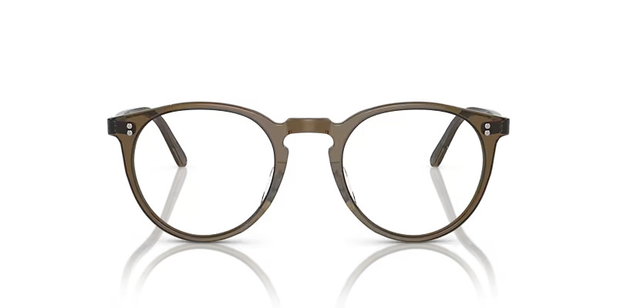
Brand | DIOR
Model Name | O MALLEY
Price | RS 2500
PRODUCT DETAILS

